**OBSTACLE AVOIDING ROBOT USING ULTRASONIC SENSORS**

**Introduction**

Now a day’s Robotics is part of today’s communication & communication is part of advancement of technology, so we decided to work on ROBOTICS field, and design something innovative which will contribute to human life in today’s aspect. There are different types of mobile robots which can be divided into several categories consisting of wheeled robot, crawling robot and legged robot. This project deals with a wheeled autonomous ROBOT. It is the part of Automation. Arobot has sufficient intelligence to cover the maximum area. This robot uses infrared sensor to detect the obstacle in between the path and then avoid them to complete its objective.

The main motto of designing such type of Robot or the technology is that this technology can be used in today’s very fast transportation to avoid the accident generally happening in congested or the Metro Politian Areas by applying emergency break. If we use this technology in the car or any vehicle, it will automatically sense the obstacles then it will take a side to the available free space. An obstacle may be a living thing or any object. Autonomous Intelligent Robots are robots that can perform desired tasks in unstructured environments without continuous human guidance. Thus by using this technology in vehicles we can drive safely.

**Materials and methods**

Components Used:

* Hardware:

1. Arduino Uno Board + Cable.
2. Ultrasonic Sensor HC-SR04.
3. Ultrasonic Sensor bracket.
4. Caster wheel.
5. H-Bridge L298N Motor Driver
6. Motors with Wheels
7. A plate
8. 2 9v batteries.
9. 2 9v batteries holders.
10. A servo motor sg90.
11. A half breadboard.
12. Jumper wires.
13. Small cardboard
14. Cable ties.

* Software:
  1. Arduino IDE

Arduino Uno Board + Cable.

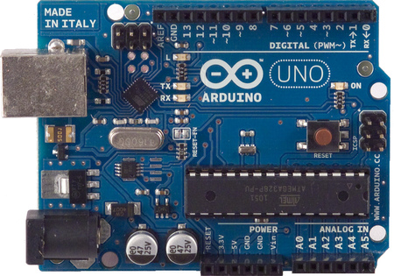

The Arduino UNO is a widely used open-source microcontroller board based on the Atmega328P microcontroller and developed by Arduino.cc. The board is equipped with sets of digital and analog input/output (I/O) pins that may be interfaced to various expansion boards (shields) and other circuits. The board features 14 Digital pins and 6 Analog pins. It is programmable with the Arduino IDE (Integrated Development Environment) via a type B USB cable. It can be powered by a USB cable or by an external 9 volt battery

Ultrasonic Sensor HC-SR04

It emits an **ultrasound** at 40 000 Hz which travels through the air and if there is an object or obstacle on its path It will bounce back to the module. Considering the travel time and the speed of the sound you can calculate the distance. The **HC**-**SR04 Ultrasonic**Module has 4 pins, Ground, VCC, Trig and Echo.

Ultrasonic Sensor bracket

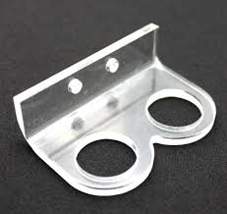

 It provide distance measurement regardless of colour and lighting of obstacles

H-Bridge L298N Motor Driver:

The L298N Motor Driver Module is a high voltage Dual H-Bridge manufactured by ST company. It is designed to accept standard TTL voltage levels. H-bridge drivers are used to drive inductive loads that requires forward and reverse function with speed control **such** as DC Motors, and Stepper Motors.

A servo motor sg90

It is tiny and lightweight motor with high output power.Servo can rotate approximately 180 degrees (90 in each direction), and works just like the standard kinds.

A half breadboard

This is a half size breadboard, good for small projects. It's 2.2" x 3.4" (5.5 cm x 8.5 cm) with a standard double-strip in the middle and two power rails on both sides

Jumper wires

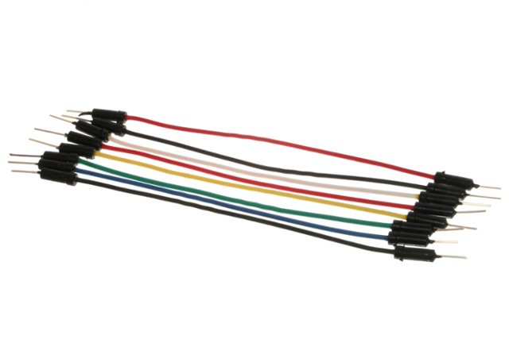

Jumper wires are simply wires that have connector pins at each end, allowing them to be used to connect two points to each other without solder

Cable ties

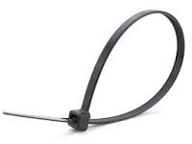

A cable tie is a type of fastener, for holding items together, primarily electrical cables or wires. Top of Form

Bottom of Form

Top of Form

Bottom of Form

Method

* First take a Bakelite sheet and cut it in to chassis form of robot.
* Cut it and join it in the form robot with the help of nut and bolts.
* Then add motor in both side at the back with the help of nuts and bolt.
* Then connect the wheel through motor and connect the caster wheel in front of chassis.
* Then connect the motor wire through motor driver.
* And connect the motor driver through power supply, Arduino and bread board.
* And connect the bread board through ultrasonic sensor.
* Now these all thing use to be fixed with chassis with nut bolt.
* At last remove bread board and connect all the wire in pcb through soldering.

**Schematic**

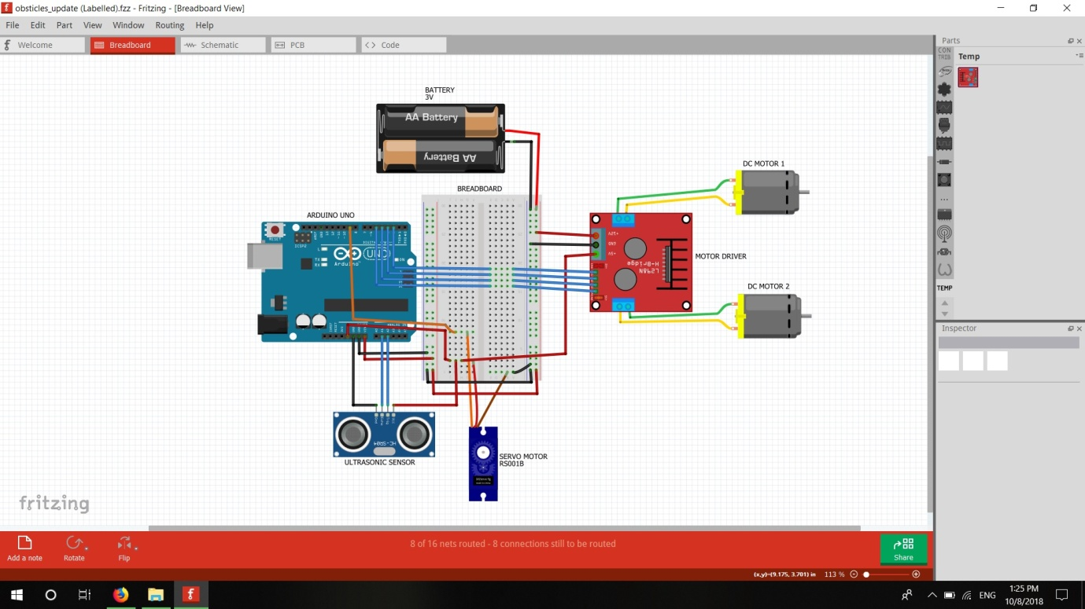

**Cad model**

**Future scope**

Top of Form

Almost all navigation robot demands the some sort of obstacle detection, hence obstacle avoidance strategy is of most importance. [Obstacle Avoidance Robot](https://www.pantechsolutions.net/robotics/obstacle-avoidance-robot) has a vast field of application. They can be used as services robots, for the purpose of household work and so many other indoor applications. Equally they have great importance in scientific exploration and emergency rescue, there may be places that are dangerous for humans or even impossible for humans to reach directly, then we should use robots to help us. In those challenging environments, the robots need to gather information about their surroundings to avoid obstacles. Nowadays, even in ordinary environments, people require that robots to detect and avoid obstacles. For example, an industrial robot in a factory is expected to avoid workers so that it won’t hurt them. In conclusion, obstacle avoidance is widely researched and applied in the world, and it is probable that most robots in the future should have obstacle avoidance function.

Bottom of Form